**SPEECH PRESENTED DURING THE ELDERS MASS ON 31ST MARCH 2024 BY EDNAH ADHIAMBO OWINO IN KUCC CHURCH AT 1.49PM**

Its nice to be here……………. Its wonderful to be here …………… Its naaaa……………. Its waaaa…………… Its naaawaa ……………… Its waanaaa……………….

It’s indeed nice and wonderful to be here. We as the elders of the Mighty KUCC, thank God for this far. It’s been four solid years of God’s providence, God’s protection, God’s faithfulness, God’s favors and mercies ……name them. From where I sit or rather from where am standing right now, I don’t think it’s because we are any better before Him. It’s just because of the grace and the love that He has for us.

Four years back, we stepped feet in The Kenyatta University gates and we were very much confused if not slightly confused. You want to know why? It’s because all the buildings were new and almost all faces were strange. But look at us now! We ended up family members of Kristu Mwalimu. In Father Bony we found a dad, and in KUCC we found home. If you’ve not found home here, then am afraid you are really missing a lot, and again, am tempted to say you probably don’t belong and participate. Forgive me if my words are a little harsh!

We thank Father for always bringing other priests and sisters to share moments with us. We are always learning a lot. Moreso, we are grateful to Father for bringing the Vincentian Retreat Team here. We were really rejuvenated. We also thank the alumni and the parents in here, for always motivating us and giving us moral support.

Allow me boldly tell you why I have enjoyed my stay here. I personally found sons and daughters in St. Andrew family, brothers and sisters in St. Francis of Assisi Jumuiya, friends in KUCC and confidants in my two good friends that is _ Chrispinus Ombango and Ian Githaka. If you think I owe you an explanation for having two handsome friends, then meet me at the tent outside church after mass.

The other reason among several others why I found home in KUCC is this. I lost my biological sister who was a form one at Joytown Thika on 24th October 2024. I had been with her two days earlier for an interview to fly to the United States for a one-year exchange programme, and she passed on the third night after passing the interview. I was so much devastated. My life lost meaning for a while and I even had suicidal thoughts. I couldn’t think straight for a month plus and I almost lost myself to mourning my sister. A moment of silence in honor of Maryvianne Atieno Owino……………………

Thank you for honoring her. My healing hasn’t been instant and am afraid it could be a lifelong process because we are talking about my best of friends.

The KUCC members held my hands and stood with me both financially and emotionally. If I didn’t belong, I don’t even know where I could have buried my head. They even bought me candles that I used for her candle lighting session, that took place where I reside in KM. I never spent a night alone, and my house was always flooded during the day with KUCC members, friends and classmates. Am forever grateful.

The last reason I could be so unfair if I don’t mention is this. KUCC has always had fom after fom, activity after activity and refreshments after refreshments. And then, there is always Hosea or Constance holding a camera for every event. Free photoshoot, I mean! If you are unable to get that thirty or fifty shillings for photoshoot at Arboretum, then at least you’re covered. What more could you ask for? Kama umewai inama hiyo ni fault yako jamani. Ebu belong na uparticipate.

As I exit this platform, I urge all of you to be checking up on your friends. Many are depressed like I was. But I conquered the battle through the power of friendship, daily masses and faith in Him that created me.

To the other students, as you look forward to wearing that graduation gown just like the elders are, I pray that God increases your faith, enlarges your boundaries and expands your territories. May the rest of your days in KU be blessed as God continues to be glorified in KUCC, and far and beyond.

To the elders, tarmacking is not our portion in Jesus’s name! May we never lack! May our pockets never run dry! May our cups overflow!

I have been in the School of Health Sciences, from the Department of Health Management and Informatics pursuing a Degree in Health Records and Information Management. Here in KUCC, I have been serving as the Family Mum of St. Andrew from the Jumuiya of St. Francis of Assisi for two terms, under the leadership of our able moderators, Kisaka Moni and Collins Mwiti.

Owino Adhiambo Ednah is my name. God bless you! God bless me! God bless KUCC! God bless Kenyatta University! God bless Kenya!

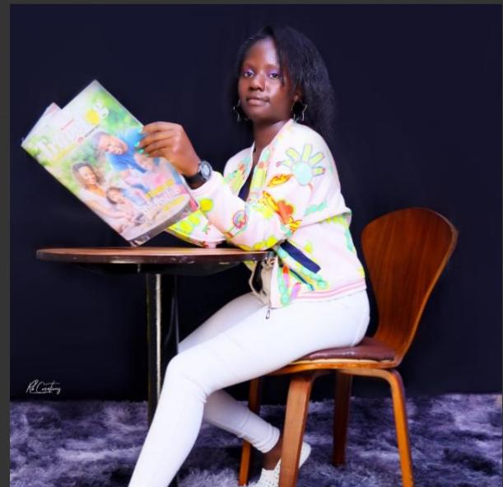

**Prepared and presented by,**

Owino Adhiambo Ednah

2024 Elder

**0746843865**

[ednah72adhiambez@gmail.com](mailto:ednah72adhiambez@gmail.com)